A000-Mex-Olmec- Jaguar Shaman-1100 BCE

MASTER !

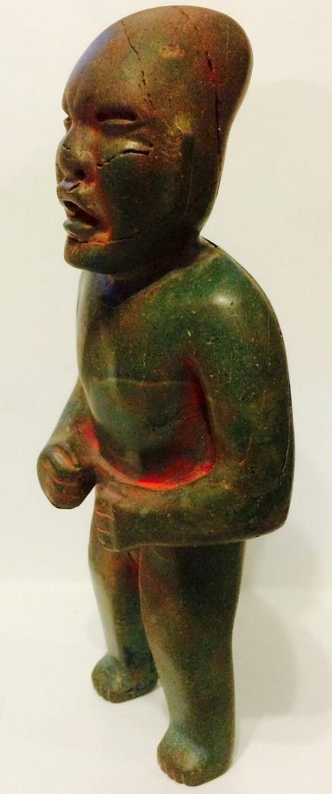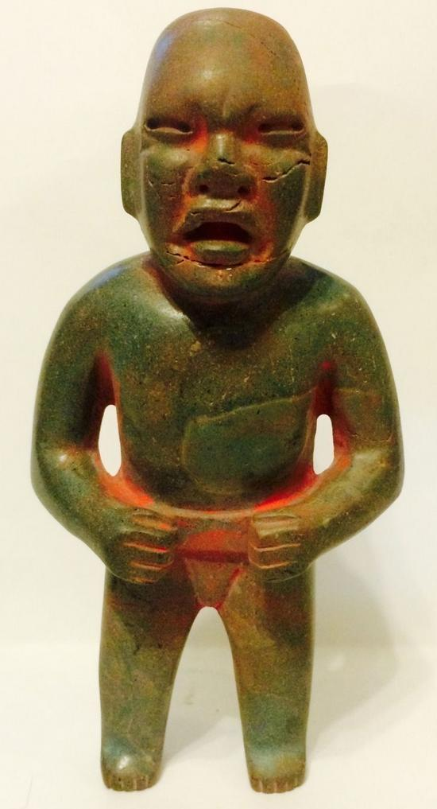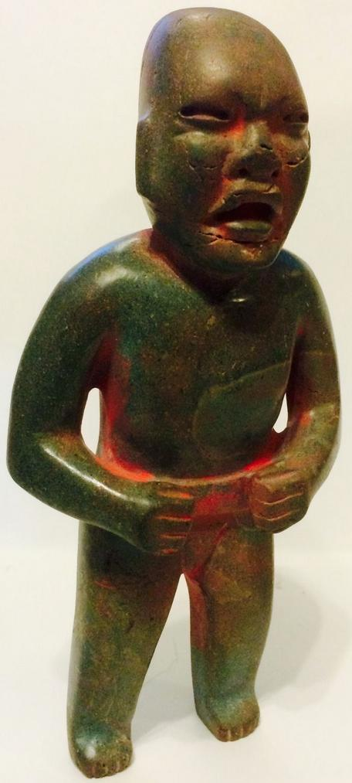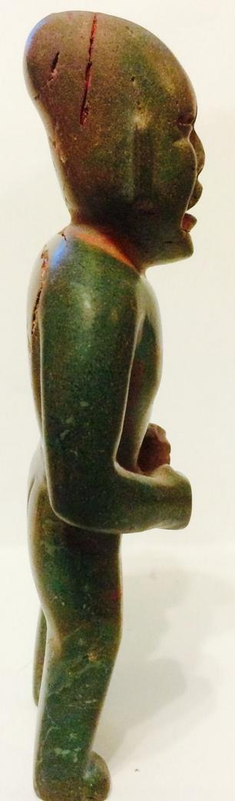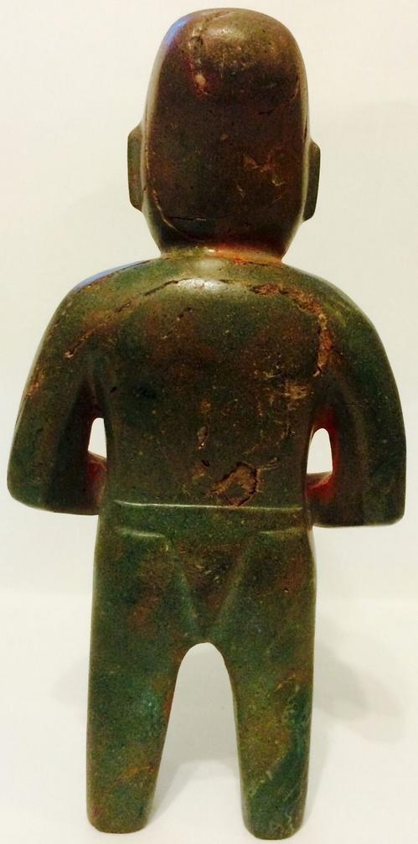

Figs. 1-5. Olmec-Were Jaguar Shaman-1100 BCE

Case no.: 14

Accession Number:

Formal Label: Olmec-Were Jaguar Shaman-1100 BCE

**Display Description:**

This is a were-jaguar transformation statuette that emphasizes the feline wrinkles around the nose and the upcurving lips. It was found in Campeche in the early 60's and imported to the US. It depicts a jaguar shaman with an elongated skull on which traces of cinnabar have been applied in ceremonial activities. Erosion of the jade due to weathering is throughout the piece. It was probably placed in a shrine to which devotees were given a new identity, perhaps that of were-jaguar ancestors, because the Olmecs believed that, in the distant past, a union between a woman and a jaguar produced an earlier race of were-jaguars. The Olmecs worked mainly in stone and used jade to suggest the life-giving aspect of the were-jaguar conversion.

**LC Classification:**

Date or Time Horizon: 1100 BCE

Geographical Area: possibly La Venta

**Map:**

**GPS coordinates:**

Cultural Affiliation:

Media:

Dimensions: H 6in, D 1 ½ in, W 3 in

Weight:

Condition: original

Provenance:

**Discussion:**

The Olmecs, the earliest known settled civilization of Central America, lived in the low-lying Gulf Coast area of what is now Mexico in about 1200-400 BCE at sites such as San Lorenzo, Tres Zapotes, Laguna de los Cerros and La Venta.

These and the other Olmec centers were well planned and included many of the features that would be associated with later civilization in Central America including the Mexica (Aztecs) and Maya. Alongside impressive public spaces and large platform-mounds made of earth, there is evidence of a ceremonial ball game and complex astrological calendars.

**References:**

.

Sold by [eckbalam2012](http://myworld.ebay.com/eckbalam2012) ( [85](http://feedback.ebay.com/ws/eBayISAPI.dll?ViewFeedback&userid=eckbalam2012) )

### Delivery package 1 of 1

Estimated delivery Wednesday, Oct 7, 2015 - Saturday, Oct 10, 2015

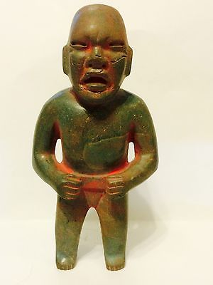

#### [Pre columbian Transformation Olmec green stone standing figure.](http://www.ebay.com/itm/271983678640)

|  |  |
| --- | --- |
| Item price | $2,000.00 |
| Quantity | 1 |
| Item number | 271983678640 |
| Shipping service | USPS Priority Mail |

## Shipping address

Ralph J Coffman Jr

149 Atlantic Ave

Swampscott MA 01907-2427

United States

## Order total

|  |  |
| --- | --- |
| Subtotal | $2,000.00 |
| Shipping | $6.40 |

**Total**

$2,006.40